**Exercise – 3**

**Due: 01-Sep-2023**

**Design the following form with proper controls and validations**

**Question 1**

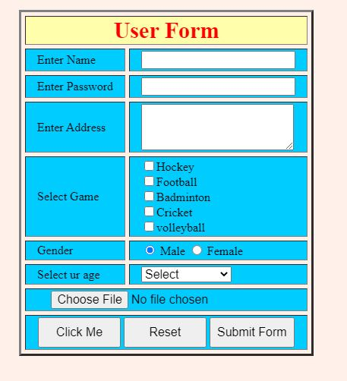

**Question – 2**

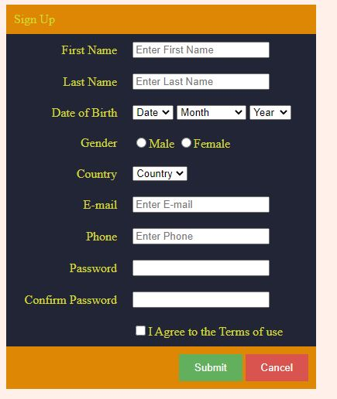

**Question – 3**

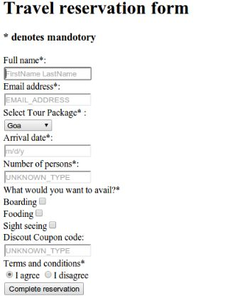

**Question – 4**

